Answer sheet:

1. What level of measurement are the following variables? (nominal, ordinal, or interval/ratio)

a) HRS1 ___________________

b) MARITAL ___________________

c) AGE ___________________

d) DEGREE ___________________

e) RELIG ___________________

f) PILLOK ___________________

2. Which measures of central tendency (mean, median, mode) would you calculate for each variable? (They could have multiple measures, depending on the level of measurement)

a) HRS1 ___________________

b) MARITAL ___________________

c) AGE ___________________

d) DEGREE ___________________

e) RELIG ___________________

f) PILLOK ___________________

3. Based on the output, write one sentence interpreting the measure of central tendency for the following variables. (mode, median and mean)
For example, The most frequent answer, or mode, for the question “what is your marital status” is: married.

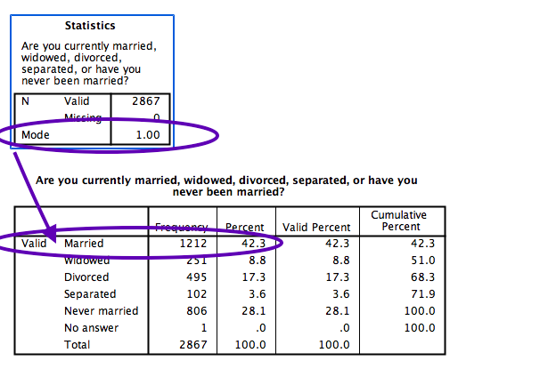

a. ________________________________________________________________________________________________
________________________________________________________________________________________________

b.
________________________________________________________________________________________________
________________________________________________________________________________________________

c.
________________________________________________________________________________________________
________________________________________________________________________________________________

4. Interpret the charts in 1-2 sentences.

a. ________________________________________________________________________________________________
________________________________________________________________________________________________

b.
________________________________________________________________________________________________
________________________________________________________________________________________________

5. Write two sentences interpreting this crosstabs chart. See examples from class and the resource on Blackboard.

________________________________________________________________________________________________
________________________________________________________________________________________________

________________________________________________________________________________________________
________________________________________________________________________________________________

